**Create Google Email Account - Gmail**

1. URL Address: **accounts.google.com/signup**
2. Fill out the form.Select Next

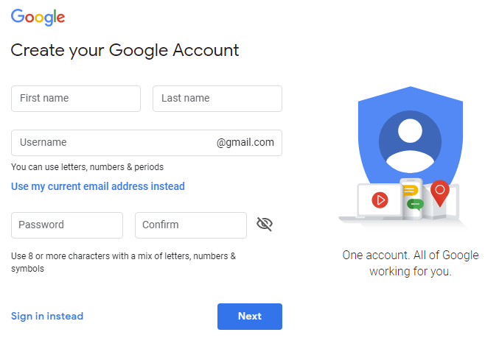

1. Fill out the Welcome page and select Next

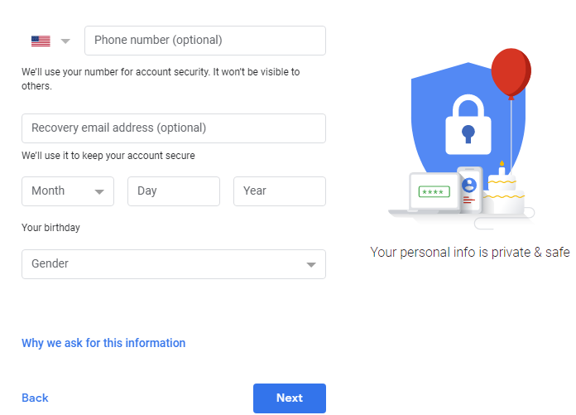

1. 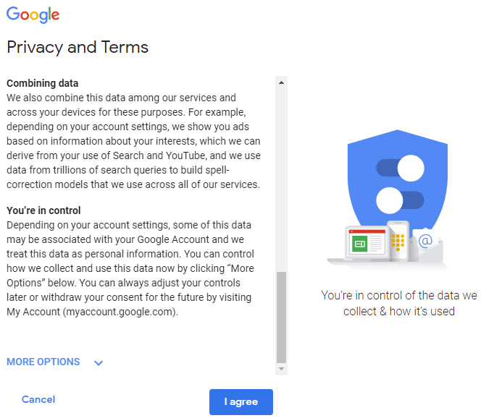Scroll to the bottom of the Privacy and Terms Page and select I agree.
2. To access your email account (Gmail), click on the menu icon found on the right of the screen: and select Gmail.

You can go directly to your email by going to the following **website: mail.google.com**

